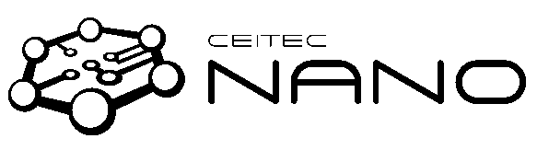 

**User fee payment at the CEITEC Nano research infrastructure**

for calendar / academic year ………………………………

**Sponsor / financial guarantee:**

Name: ………………………………………………….………………………………………………… Institution: ………………………………………………………..……………………………………… E-mail: …………………………………………………………………………………………………… Phone: ……………………………………………………………………………………………………

The Sponsor agrees to pay the fee of **30 000 CZK per year** for services and consumables provided by CEITEC Nano research infrastructure.

The fee will be payed:

by purchasing consumables for CEITEC Nano by invoice payment for CEITEC Nano services

by payment from budget for CEITEC PhD students

**User of the research infrastructure**, for whom the fee is payed:

The User and the Sponsor are the same person.

Name: ………………………………………………….………………………………………………… Institution: ………………………………………………………..……………………………………… E-mail: ……………………………………………………………………………………………………

Phone: ……………………………………………………………………………………………………

The User agrees to acknowledge the CEITEC Nano research infrastructure in all publications resulting from the research performed on infrastructure instrumentation. The User explicitly declares to obey fully the rules of access to the CEITEC Nano research infrastructure as stated in the CEITEC Nano User Manual.

Date and signature of the User: ………………………………………………

Date and signature of the Sponsor: ………………………………………….

Brno University of Technology | IN: 00216305

CEITEC BUT – Central European Institute of Technology Purkyňova 123, CZ-61200 Brno, Czech Republic [www.ceitec.eu](http://www.ceitec.eu/) | [info@ceitec.vutbr.cz](mailto:info@ceitec.vutbr.cz)

 

**User solemn declaration at the CEITEC Nano research infrastructure**

The prerequisite for charging the price for academic users is the signing of the affirmation below:

I, *[insert full legal name]:* ………………………………………………………………………

born on *[insert date of birth]:* ……………………………………..

do hereby solemnly and sincerely declare that the results of measurement will be used for the purpose of independent research only and will not be provided or sold to any third parties.

Declared at *[insert place of declaration]* ……………………………………..

Date and signature of the declarant: …………………………………………………………

Brno University of Technology | IN: 00216305

CEITEC BUT – Central European Institute of Technology Purkyňova 123, CZ-61200 Brno, Czech Republic [www.ceitec.eu](http://www.ceitec.eu/) | [info@ceitec.vutbr.cz](mailto:info@ceitec.vutbr.cz)